QR Code Based Attendance System

In this project we are designing QR code based employee attendance system and this project consist of two modules

1. Admin module: admin can login to application by using username and password as ‘admin’ and ‘admin’ and then can ADD New Employee Details and then application will generate QR CODE on EMPLOYEE ID and then admin can download that image and give to employee and employee can show that image to QR CODE scanner to mark attendance. Admin can view all employee details and then can view employee attendance by using start and end date.
2. Employee Login Module: employee can login to system by using his ID and can view his attendance from start and end date selection
3. QR CODE WEBCAM SCANNER: employee has to show his QR CODE image from his mobile to webcam and then webcam will read QR CODE and mark attendance. Only one attendance for each employee for each day will be marked.

All details will be stored in MYSQL database and to run project install MYSQL database and PYTHON 3.7 and then copy content from ‘DB.txt’ file and then paste in MYSQL console to create database.

Now double click on ‘run.bat’ file to start python web server and get below screen

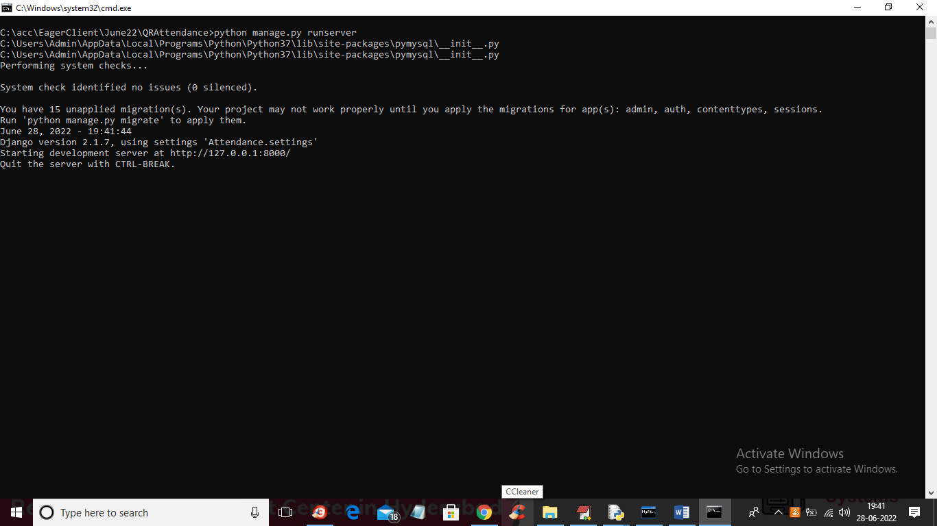

In above screen python web server started and now open browser and enter URL as ‘http://127.0.0.1:8000/index.html’ and press enter key to get below page

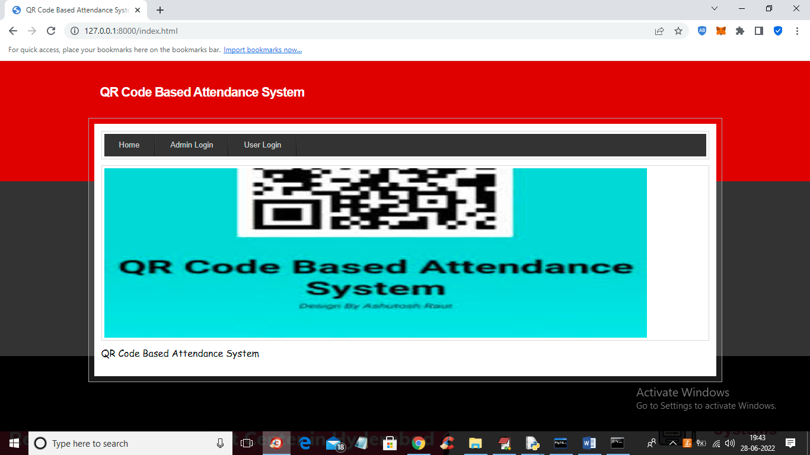

In above screen click on ‘Admin Login’ link to get below login screen

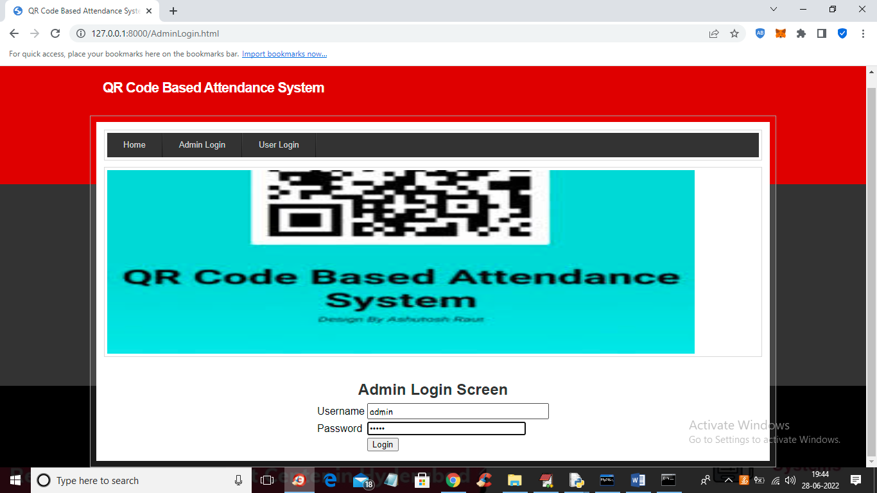

In above screen admin is login and after login will get below screen

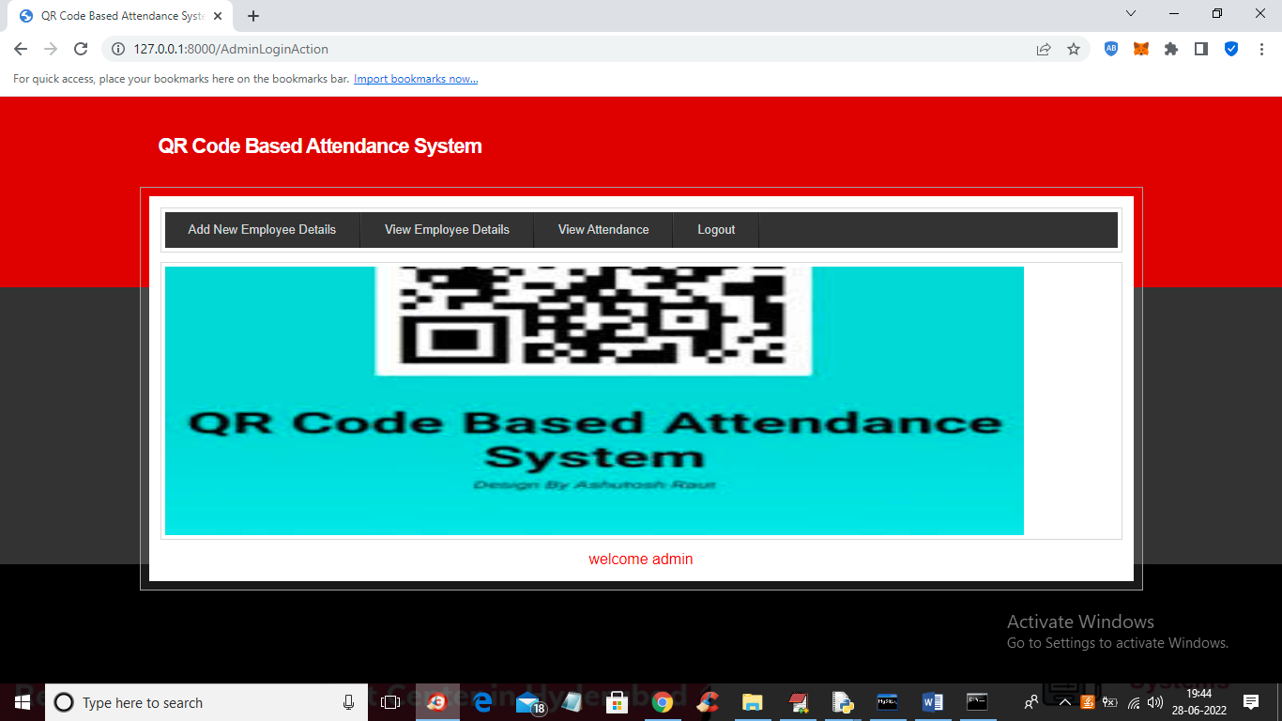

In above screen admin can click on ‘Add New Employee Details’ link to get below screen to add employee details

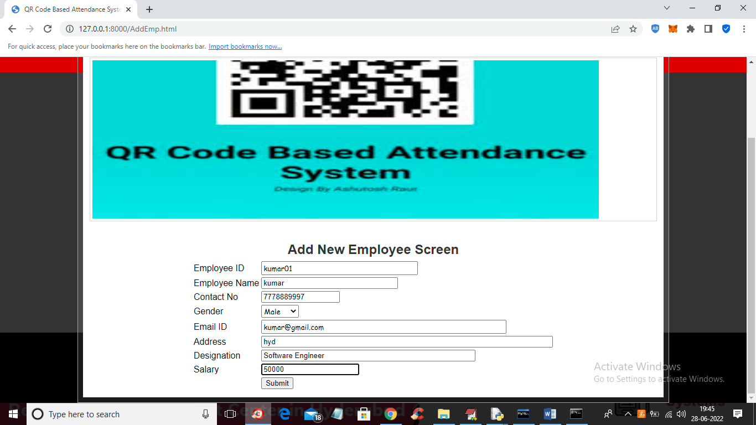

In above screen admin is adding NEW Employee Details and then press button to get below screen

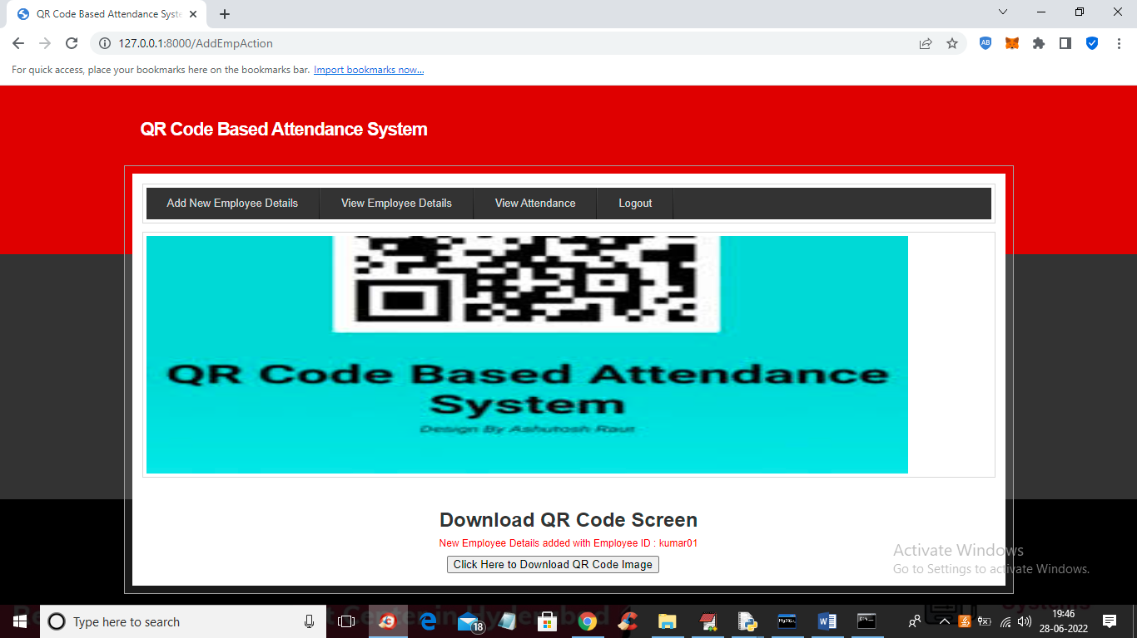

In above screen employee details added and now click on ‘Click Here to Download QR Code Image’ button to download QR image and get below output

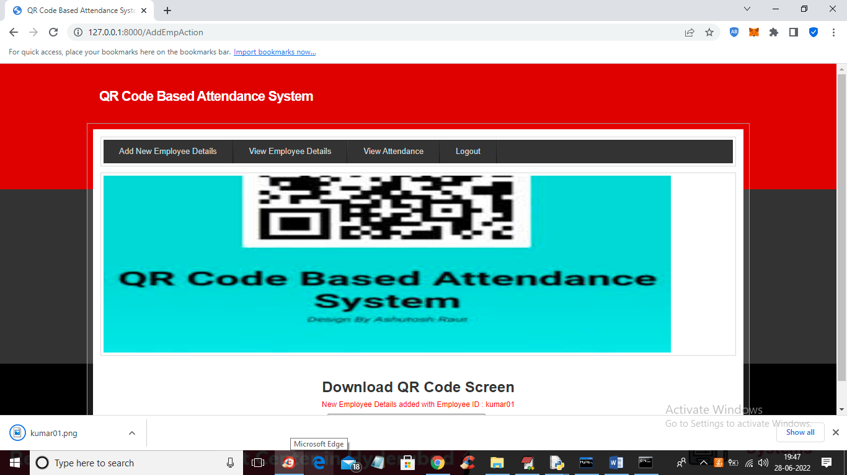

In above screen in browser status bar we can see QR image is downloaded and admin will give this image to employee and he can saved this image in mobile and then can show this image from his mobile to WEBCAM to mark his attendance and now open that image and view QR CODE like below screen

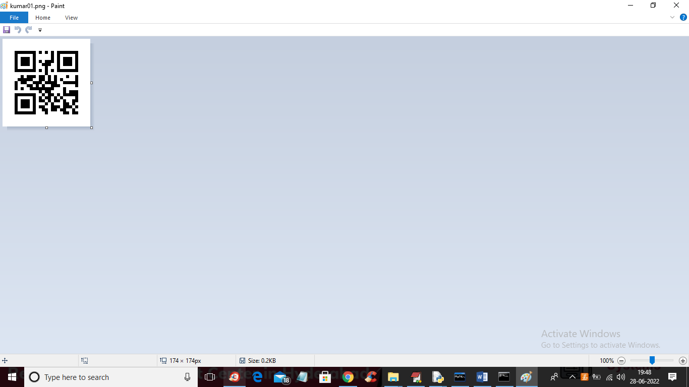

In above screen we can see QR code and now in application click on ‘View Employee Details’ link to get below details

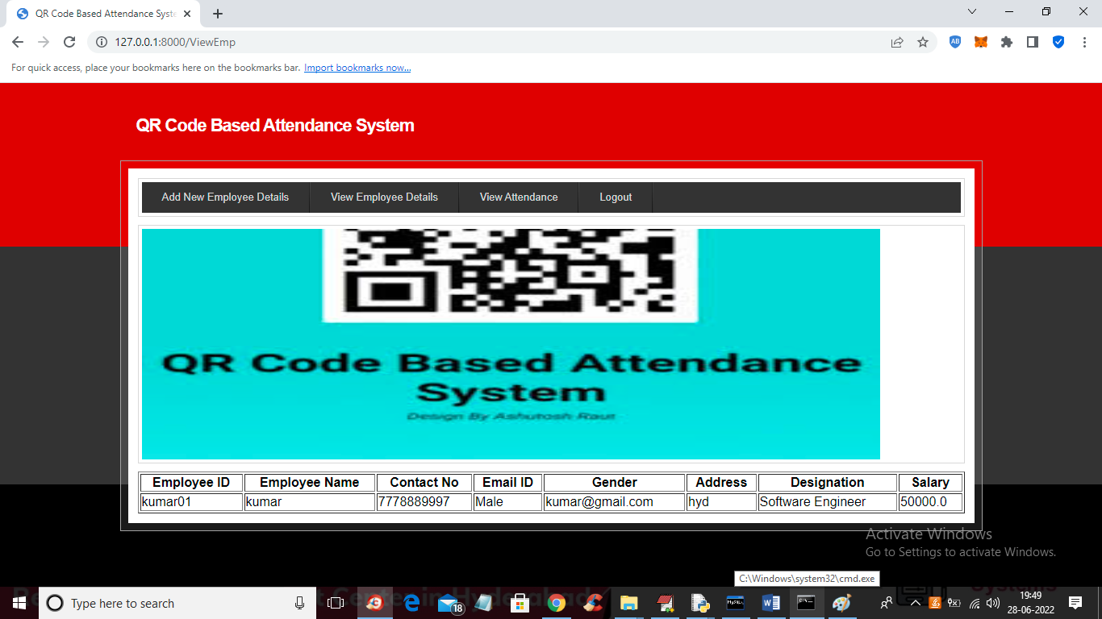

In above screen admin can view all employee details and now to mark attendance double click on ‘RunWebCam.bat’ file to get below screen

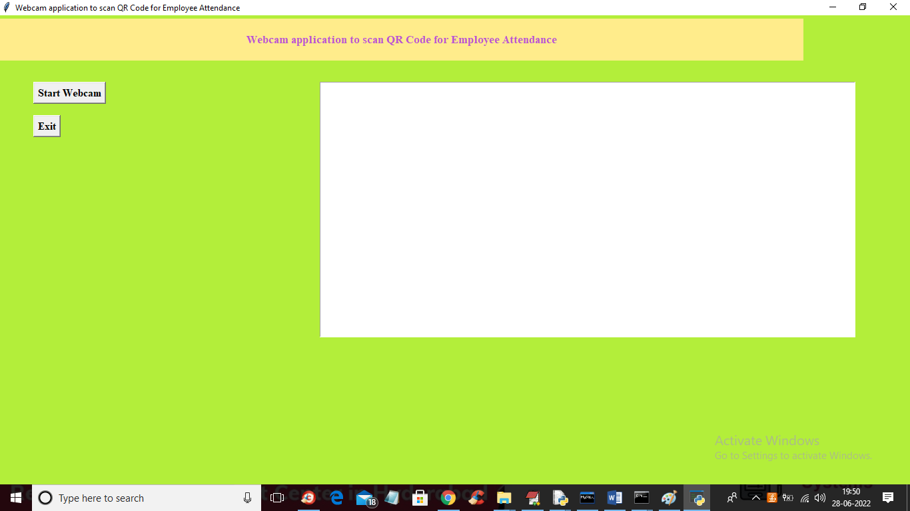

In above screen click on ‘Start Webcam’ button to start web cam and get below screen

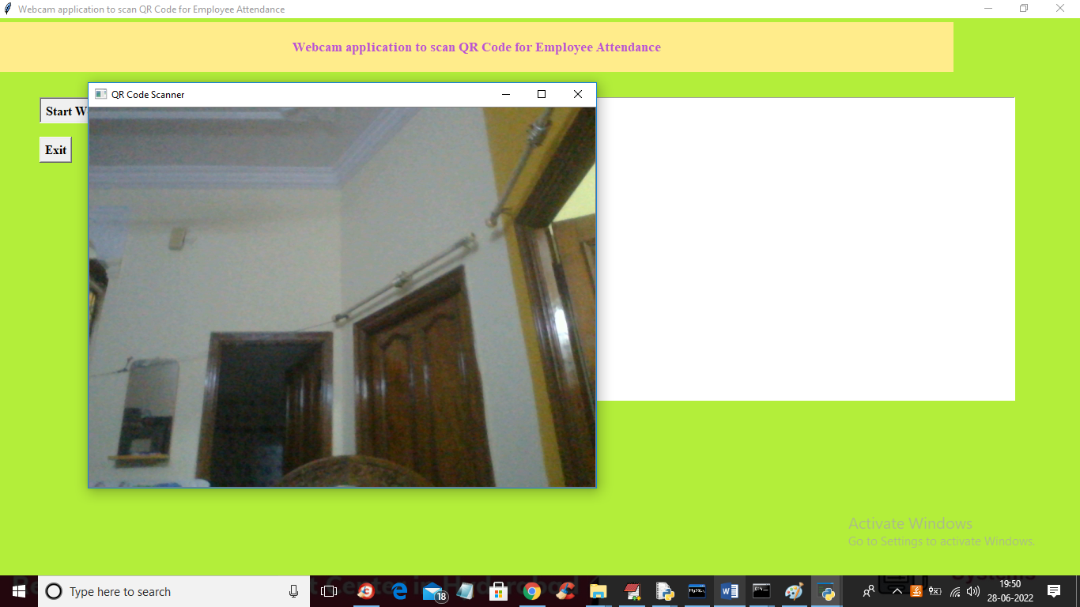

In above screen webcam started and now employee has to show QRCODE from his mobile like below screen and once QR code detected then system will mark attendance

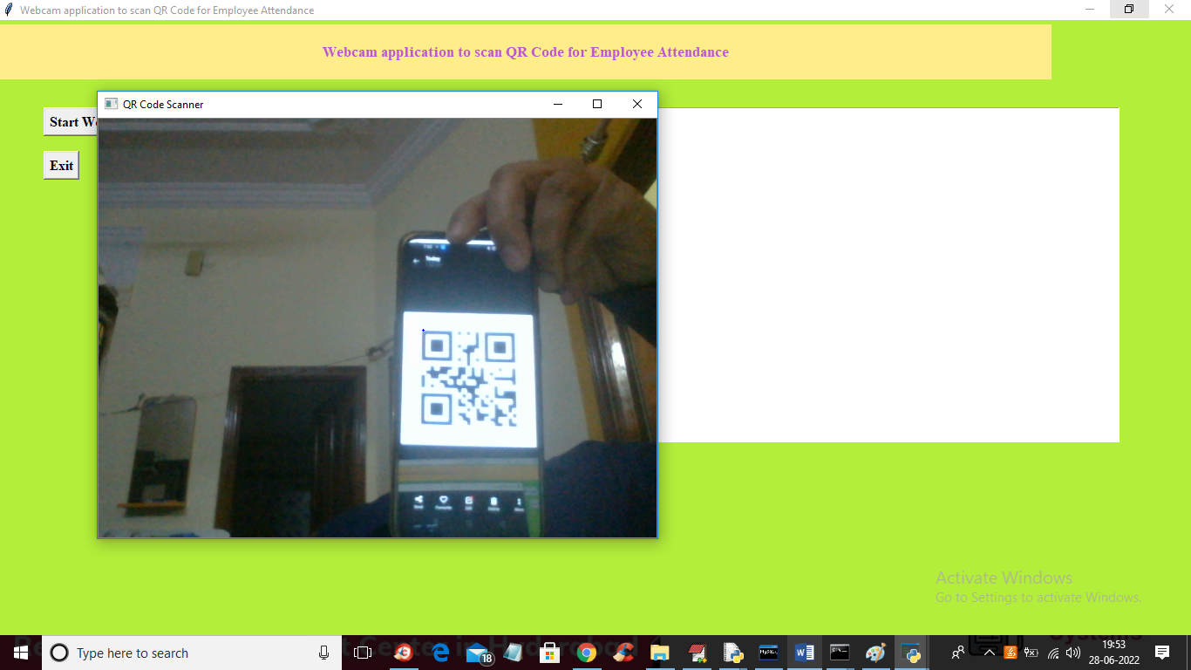

In above screen to webcam I am showing QRCODE and once detected then will get below screen

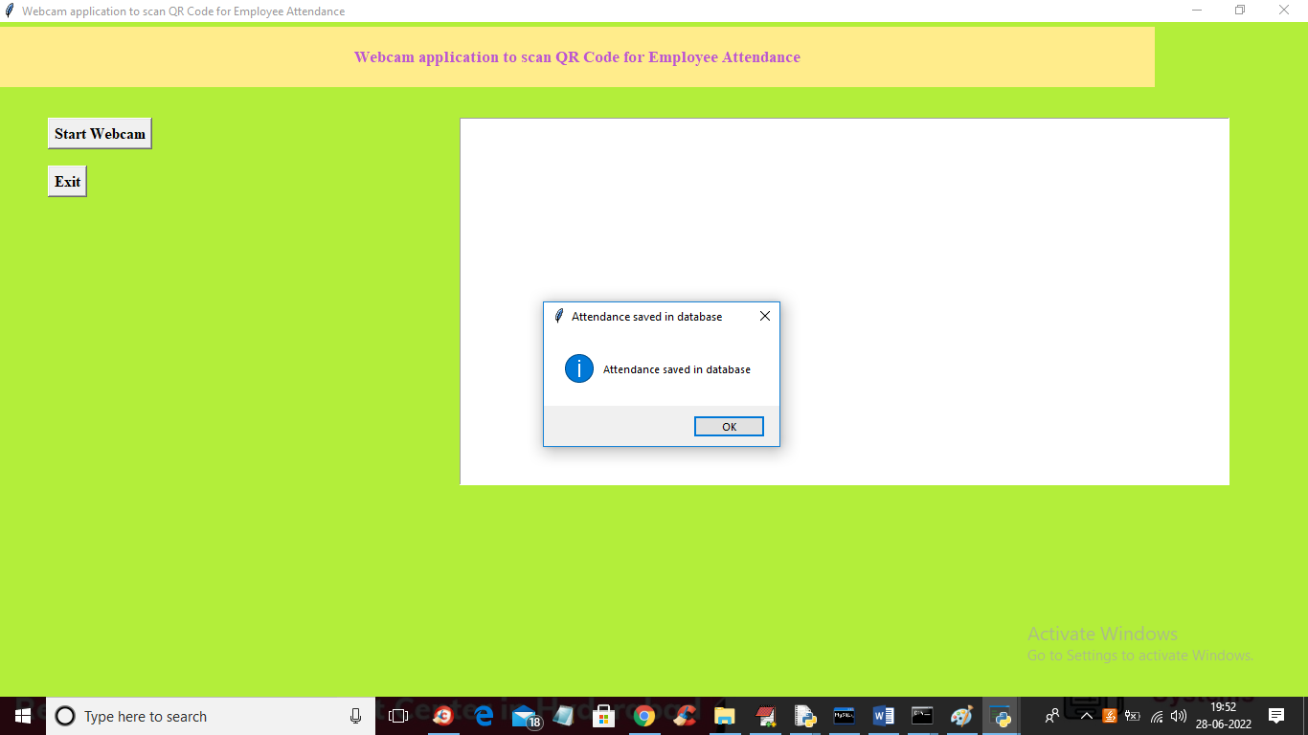

In above screen we got dialog box saying ‘attendance saved in database’ and each employee each day only one time webcam will scan his QRCODE and if he want again then delete all rows from database. Now go to previous application and then click on ‘View Attendance’ link like in below screen

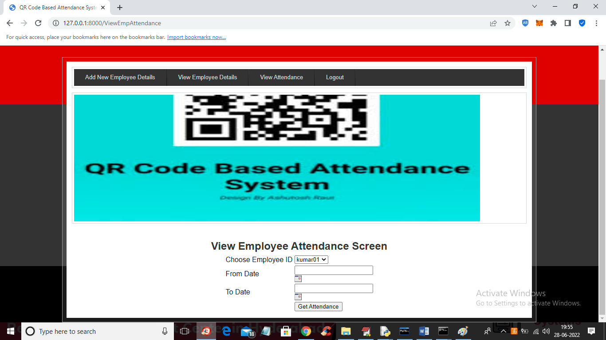

In above view attendance screen admin can view all employee names in drop down box and he can select desired employee name and then choose start and end date like below screen

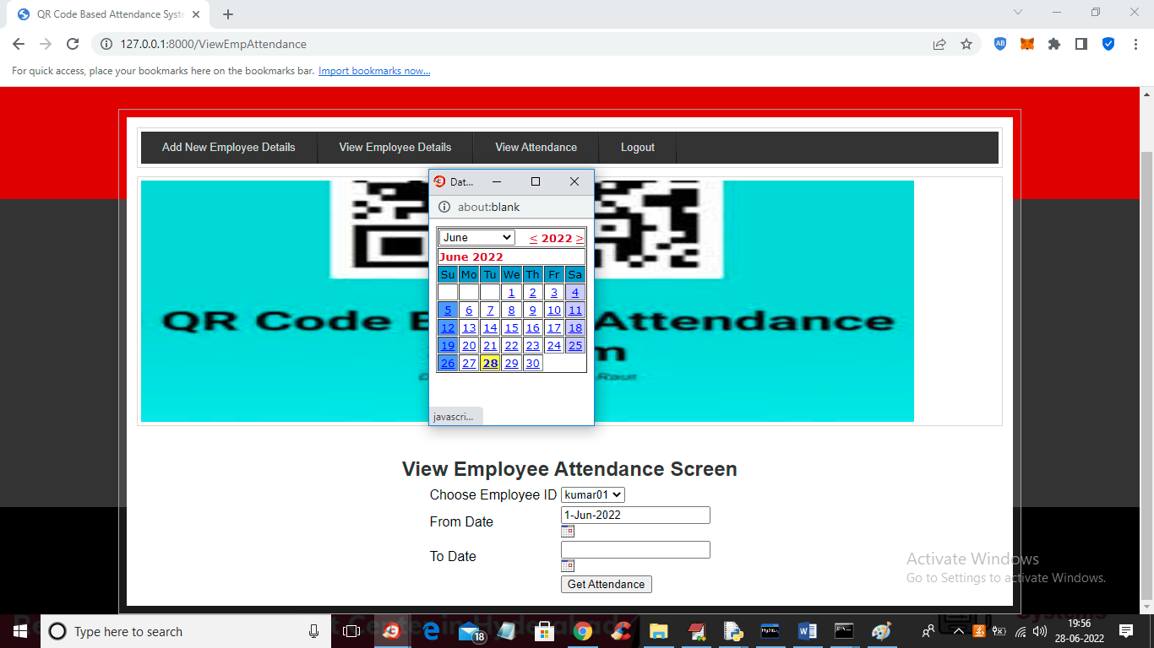

In above screen admin selected employee id and then select start and end date and then press ‘get Attendance’ button to get below screen

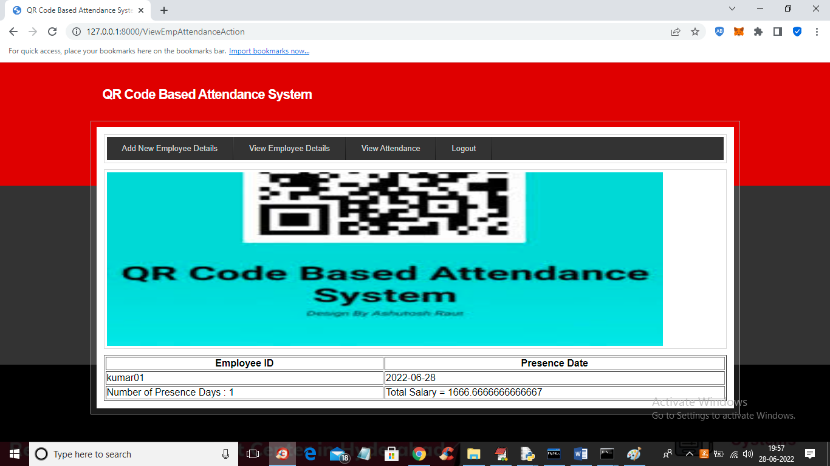

In above screen in first column we can see employee ID and in second column we can see date on which he was present and in last column we can see his payable salary by calculating all present days. Now logout and login as employee

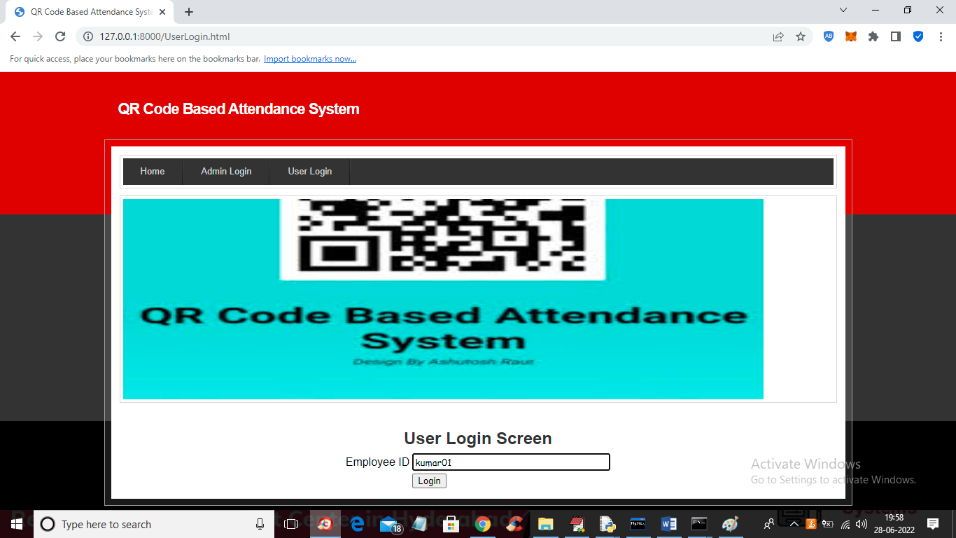

In above screen employee can login by using his ID and then press button to get below screen

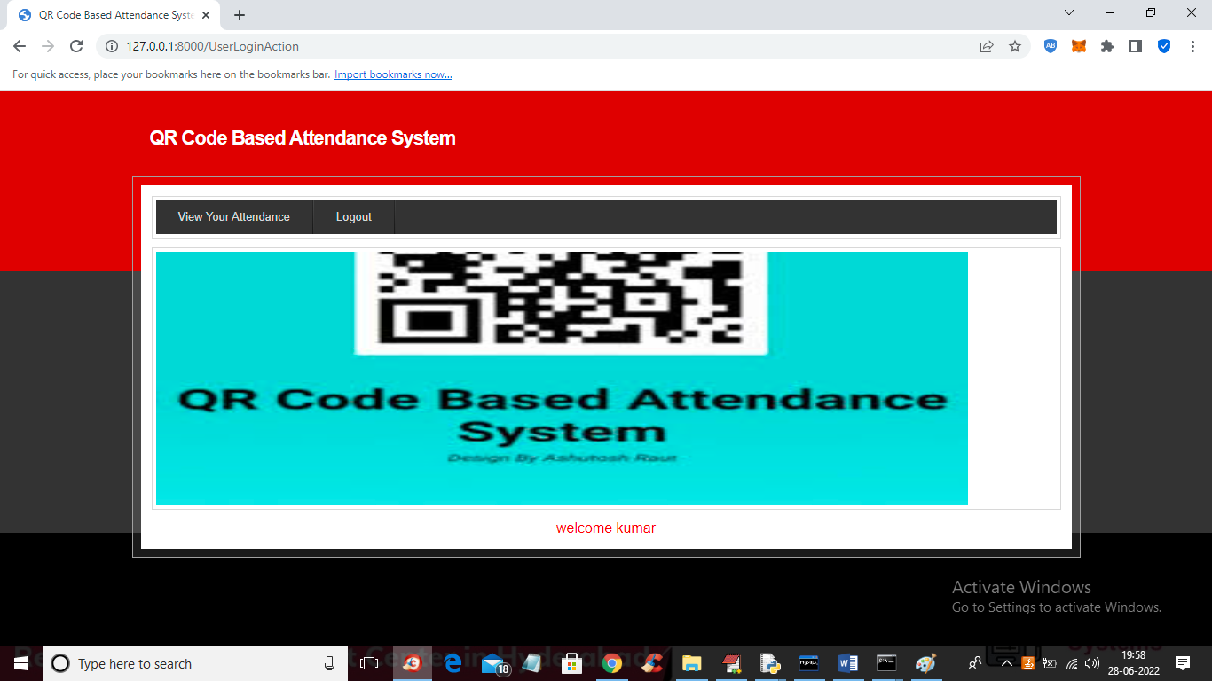

In above screen employee can click on ‘View Your Attendance’ link to get below screen

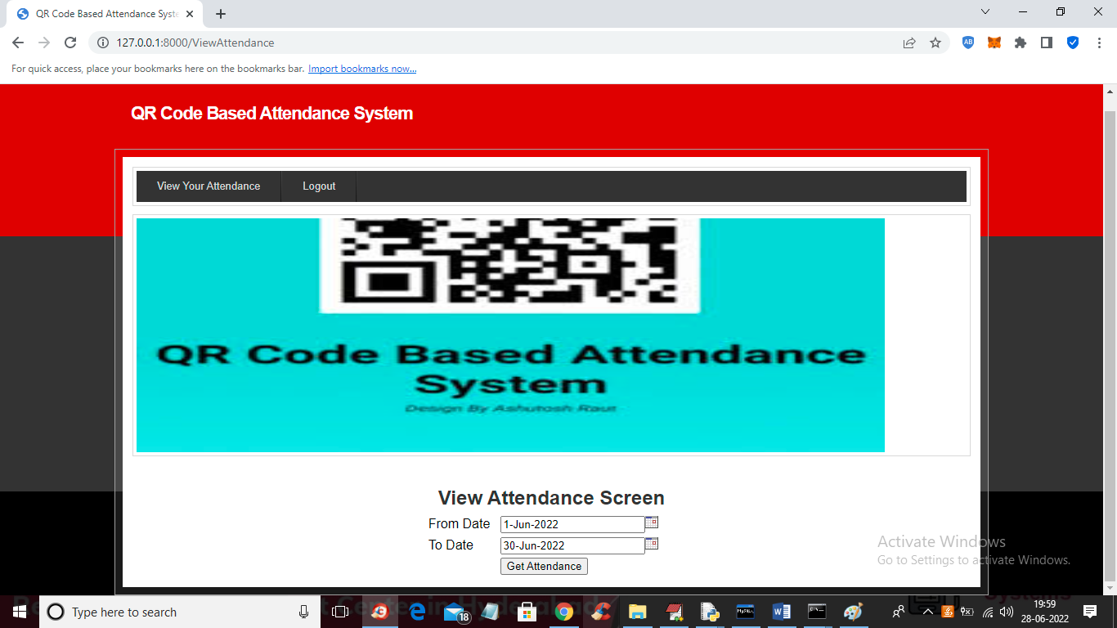

In above screen employee can select start and end date and then press button to view his attendance for selected days

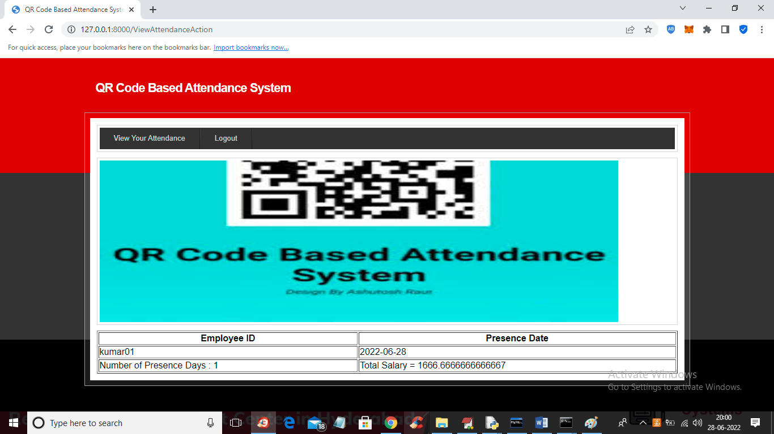

In above screen employee can view all present days date and current payable salary.

Similarly you can add any number of employees and go for attendance and view it